**Output:-**

Open the other command prompt and give the following command.

Kindly note the port number that you will get in the previous command prompt and change the port number in the curl

1. Getting the List of Items

curl --insecure <https://localhost:7010/api/glossary>  
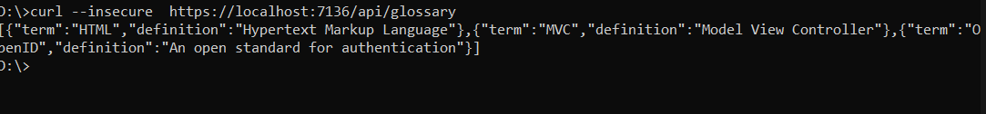

1. Getting Single Item 
   1. curl --insecure <https://localhost:7010/api/glossary/MVC>



* 1. curl --insecure <https://localhost:7010/api/glossary/HTML>

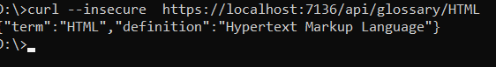

* 1. curl --insecure <https://localhost:7010/api/glossary/OpenID>

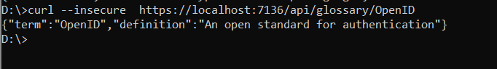

1. Creating an item

curl --insecure -X POST -d "{\"term\": \"MFA\", \"definition\":\"An authentication process.\"}" -H "Content-Type:application/json" <https://localhost:7010/api/glossary>



1. Updating an Item  
   curl --insecure -X PUT -d "{\"term\": \"MVC\", \"definition\":\"Modified record of Model View Controller.\"}" -H "Content-Type:application/json" <https://localhost:7010/api/glossary>

5. Delete an Item  
curl --insecure --request DELETE --url <https://localhost:7010/api/glossary/openid>

